REVISION LAB Output Snippets

Task-1A

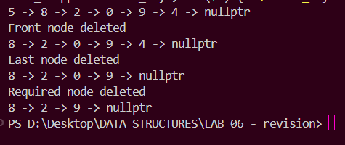

Task-1B

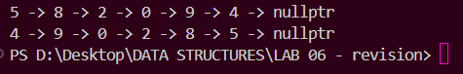

Task-2A

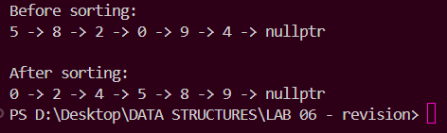

Task-2B

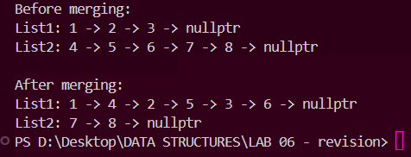

Task-3

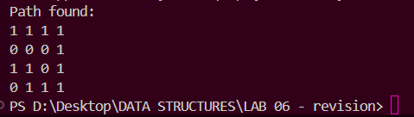

Task-4

